**Solve the quiz on a piece of paper with your name, signature and registration number on top of the page. Take a snapshot of your solution and paste it in this document and submit it.**

Q: Find the shortest path lengths, using the following graph, from ***source node 1*** to all the other nodes using Dijkstra’s Single Source Shortest Path algorithm.

Show all the calculations by completing the ***table*** as done in the class.

***(Look at the Lecture Notes in the Teams for the table calculations.)***

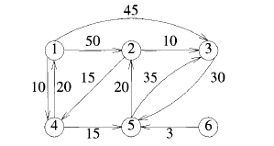

**Ans:**